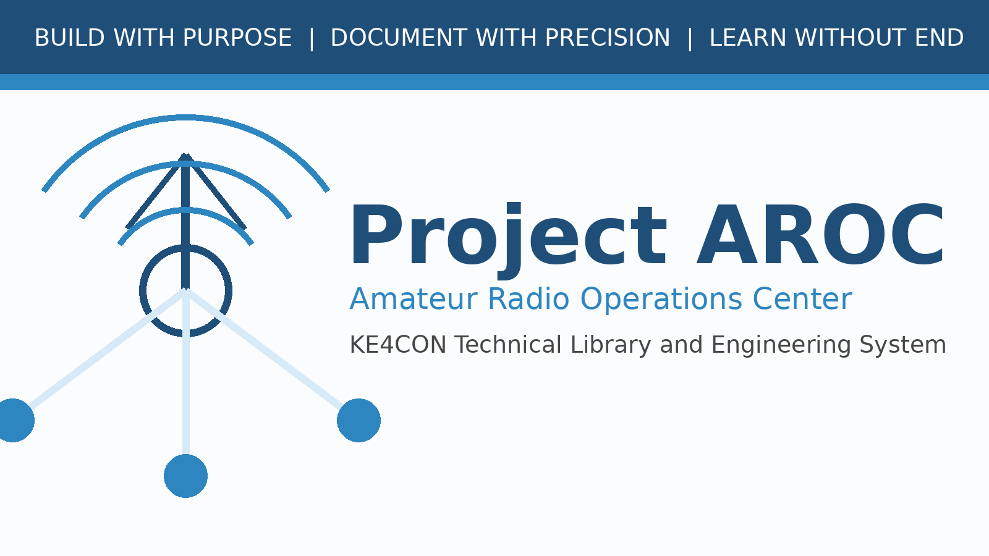

Project AROC Visual Identity Guide
Milestone 0003A - Branding and Style Reference

Document Number | AROC-BRAND-0001
Revision | 0.1
Status | Draft for Review
Project | Project AROC - KE4CON
Motto | Build with Purpose. Document with Precision. Learn without End.

Document Control
Document Number | AROC-BRAND-0001
Title | Project AROC Visual Identity Guide
Revision | 0.1
Status | Draft for Review
Owner | James / KE4CON
Technical Author | ChatGPT
Applies To | Project AROC Technical Library and Engineering Documentation

Revision History
Revision | Date | Author | Description | Status
0.1 | 2026-06-30 | ChatGPT | Initial milestone 0003A publication framework draft | Draft

Table of Contents
1. Identity
2. Logo Usage
3. Color Palette
4. Typography
5. Cover Page Design
6. Callout Styles
Note: In later releases, this placeholder will be replaced with an automatic Word table of contents field.

1. Identity
Project AROC is the KE4CON Amateur Radio Operations Center. Its visual identity should communicate technical competence, reliability, amateur radio heritage, and long-term maintainability.

2. Logo Usage

The draft logo may be used on cover pages, website landing pages, internal project documents, and presentation title slides. It may be revised in future releases without changing the underlying document structure.

3. Color Palette
{
"aroc_navy": "#1F4E79",
"aroc_blue": "#2E86C1",
"aroc_light_blue": "#D6EAF8",
"aroc_gray": "#F2F4F4",
"aroc_dark_gray": "#444444",
"aroc_green": "#1E8449",
"aroc_orange": "#CA6F1E",
"aroc_purple": "#6C3483"
}

4. Typography
- Body text should prioritize readability over decoration.
- Technical examples should use a monospaced font.
- Headings should be high contrast and easy to scan.

5. Cover Page Design
The standard cover page uses the Project AROC logo, document title, document number, revision, project owner, status, and motto. Covers should be visually consistent across the entire library.

6. Callout Styles
Engineering Note
Blue callout for technical explanations.

Design Decision
Orange callout for design reasoning.

Future Expansion
Purple callout for ideas deferred to later releases.

